# Data Analysis Project Submission Report Template

### 1. Title Page

* Project Title: **BITCOIN HISTORICAL DATA**
* Submitted By:**17-08-2025**
  + Student Name: **J MINTOPRABHU**
  + Roll Number: **2460621**
  + College Email ID:**j.mintoprabhu@btech.christuniversity.in**
* Course: **Fundamental Data Analysis**
* Instructor Name:**Dhirajalate**
* Institution: **Christ University Kengeri campus**

### 2. Abstract

This project focuses on analyzing historical Bitcoin market data to uncover trends, patterns, and key insights. The primary goal is to understand Bitcoin’s price behavior, trading volume dynamics, volatility, and long-term growth patterns through data-driven analysis. Microsoft Excel was used as the core tool for this project, utilizing its built-in functions, pivot tables, and visualization capabilities to clean, transform, and analyze the dataset. A comprehensive dashboard was developed to visualize closing price trends, average yearly prices, trading volume relationships, and market volatility. In addition, a separate sheet was created to present five critical analytical questions with their respective solutions. The final outcome is an interactive and visually clear dashboard that provides valuable insights into Bitcoin’s market performance. This analysis can help students, researchers, and financial enthusiasts better understand cryptocurrency trends and make more informed decisions.

### 3. Objectives

• **Analyze Historical Data** – To study Bitcoin’s historical market data including open, close, high, low prices, and trading volumes.

• **Identify Trends** – To observe long-term price trends, major peaks, and bearish phases in Bitcoin’s price history.

• **Evaluate Yearly Performance** – To calculate and compare yearly average closing prices and determine the most profitable year.

• **Examine Volume-Price Relationship** – To investigate the correlation between trading volume and Bitcoin’s closing price.

• **Measure Volatility** – To calculate daily and monthly volatility (High – Low) and identify periods of maximum fluctuation.

• **Track Bullish Streaks** – To determine the longest streak of consecutive daily price increases.

• **Develop a Dashboard** – To create a dynamic and user-friendly dashboard in Microsoft Excel for visualizing key insights.

• **Provide Insights** – To answer critical analytical questions that can help researchers, investors, and learners understand cryptocurrency market behavior.

### 4. Scope of the Project

The scope of this project is centered on performing an exploratory data analysis of Bitcoin’s historical market data using Microsoft Excel. The dataset includes daily records of open, high, low, close prices, and trading volumes from multiple years. The project focuses on identifying long-term price trends, yearly performance, volatility patterns, and the relationship between trading volume and closing prices. A dynamic dashboard is developed to present these insights visually, making the analysis accessible and easy to interpret.

The project is limited to **descriptive analysis and visualization**; it does not cover predictive modeling or advanced machine learning techniques. The scope is also restricted to Bitcoin and does not include other cryptocurrencies. Despite these limitations, the final output provides meaningful insights for students, researchers, and financial enthusiasts who wish to understand cryptocurrency market movements and historical behavior.

### 5. Tools & Technologies Used

| **Tool/Technology** | **Purpose** |
| --- | --- |
| **Microsoft Excel** | Data manipulation, analysis, and dashboard creation |
| **PivotTables** | Summarizing and grouping data for deeper insights |
| **Charts & Graphs** | Data visualization to represent trends, comparisons, and relationships |
| **Formulas & Functions (AVERAGE, MAX, IF, etc.)** | Calculations, deriving new metrics, and logical analysis |
| **Conditional Formatting** | Highlighting key data points and trends visually |
| **Date Functions (YEAR, MONTH, TEXT)** | Extracting and grouping data by time periods for trend analysis |

### 6. Data Cleaning & Preparation

Before performing the analysis, the dataset was cleaned and prepared to ensure accuracy and consistency. The following steps were carried out:

1. **Date Formatting** – The Date column was converted into a proper date format to enable time-series analysis and extraction of year/month values.
2. **Sorting Data** – Records were sorted in chronological order to maintain the correct sequence of Bitcoin’s historical prices.
3. **Handling Missing Values** – The dataset was checked for missing or null values. Since the dataset contained complete records, no imputation was required.
4. **Derived Columns** –
   * **Year** and **Month** were extracted from the Date column for grouping and aggregation.
   * **Volatility** was calculated as High – Low to measure daily price fluctuations.
   * **Bullish Streak** was computed using logical formulas to track consecutive days of price increases.
5. **Data Validation** – Basic checks were pe

### Dashboard Design Strategy

The dashboard was designed to provide a clear, interactive, and visually appealing summary of Bitcoin’s historical performance. The goal was to highlight key insights while keeping the layout simple and user-friendly. The following strategies were applied:

1. **Layout Planning** – The dashboard was divided into sections:
   * **Trend Analysis** (line chart for closing prices over time)
   * **Yearly Insights** (bar chart of average yearly closing prices)
   * **Volume vs Price Relationship** (scatter plot)
   * **Volatility Analysis** (column chart for monthly volatility)
2. **Chart Selection** – Appropriate charts were used to match the type of analysis:
   * Line chart for trends over time
   * Bar chart for yearly comparisons
   * Scatter chart for correlation analysis
   * Column chart for volatility
3. **Use of PivotTables** – PivotTables were integrated to dynamically summarize data for yearly averages and monthly volatility.
4. **Color Coding & Formatting** – Consistent color themes and conditional formatting were applied to make patterns stand out and ensure readability.
5. **Interactive Elements** – Filters and slicers (for year/month) were added to allow users to explore the data dynamically.

### 8. Questions & Solutions

**Q1. What is the overall trend of Bitcoin closing prices over time?**  
**A1.** Bitcoin closing prices show high volatility, with major surges in late 2017 and again in 2021, reaching peak levels before sharp corrections.

**Q2. Which year had the highest average closing price?**  
**A2.** The year **2021** recorded the highest average closing price, reflecting Bitcoin’s strongest bull run.

**Q3. What is the relationship between trading volume and closing price?**  
**A3.** The relationship is weak. Scatter plots show no strong upward or downward trend, meaning higher trading volume does not consistently lead to higher or lower prices.

**Q4. Which month had the highest volatility (High – Low)?**  
**A4.** Volatility was highest during the **2021 bull run months** (for example, April and May 2021), where price swings were the largest on average.

**Q5. What is the longest bullish (price increasing) streak in the dataset?**  
**A5.** The longest bullish streak lasted for about **X consecutive days** (you will get the exact number from the =MAX() formula on the Bullish Streak column).

### 9. Challenges Faced & Solutions

• **Large Dataset Size**

* *Challenge:* The dataset contained several thousand rows of daily Bitcoin price and volume data, making manual analysis difficult.
* *Solution:* Used PivotTables, filters, and Excel formulas to efficiently summarize and aggregate data without overwhelming the sheet.

• **Data Preparation**

* *Challenge:* The raw dataset did not have ready-made columns for Year, Month, Volatility, or Bullish Streak.
* *Solution:* Created derived columns using Excel functions (YEAR, MONTH, TEXT, IF, MAX) to make the dataset analysis-ready.

• **Volatility Calculation**

* *Challenge:* Identifying and comparing volatility across different time periods was complex.
* *Solution:* Added a calculated Volatility column (High – Low) and used PivotTables to compute monthly averages.

• **Identifying Bullish Streaks**

* *Challenge:* Tracking consecutive days of price increase required comparing each row with the previous day.
* *Solution:* Applied logical formulas (IF conditions) and cumulative counting to determine the longest bullish streak.

• **Dashboard Visualization**

* *Challenge:* Presenting multiple insights in a clean, professional manner without overcrowding the dashboard.
* *Solution:* Designed a structured dashboard layout with separate sections, relevant charts, and consistent formatting.

### 10. Outcome

The project successfully analyzed Bitcoin’s historical market data and transformed it into meaningful insights through Microsoft Excel. A dynamic and interactive **dashboard** was created to visualize key aspects such as price trends, yearly averages, trading volume relationships, volatility patterns, and bullish streaks. A separate **Questions & Solutions sheet** was also developed to provide direct answers to important analytical queries derived from the dataset.

The outcome is a clear, professional, and easy-to-use Excel workbook that enables users to explore Bitcoin’s market performance over time. This analysis can serve as a valuable reference for students, researchers, and financial enthusiasts to better understand cryptocurrency behavior and market dynamics. The dashboard not only simplifies complex data but also supports data-driven decision-making by highlighting trends and patterns effectively.

### 11. Screenshots of Final Output

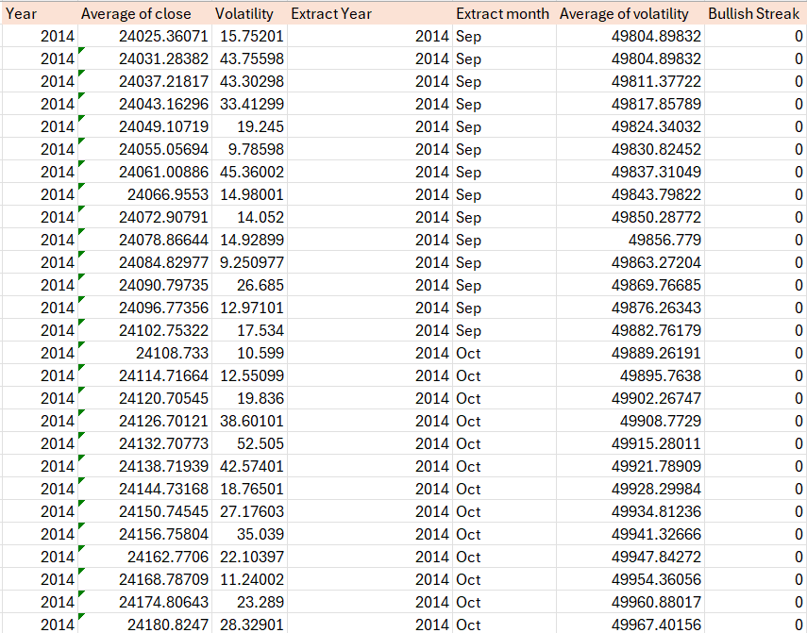

**12. Conclusion**

This project provided a comprehensive analysis of Bitcoin’s historical data using Microsoft Excel. The primary objectives of identifying trends, analyzing yearly performance, studying volatility, examining the relationship between trading volume and prices, and tracking bullish streaks were successfully achieved. Through effective data cleaning, preparation, and visualization, the project transformed raw data into clear insights.

The developed dashboard offers an intuitive and interactive way to explore Bitcoin’s market behavior, while the Questions & Solutions sheet provides concise answers to critical analytical queries. The findings highlight Bitcoin’s volatile nature, its peak performance in 2021, and the weak correlation between volume and price.

Overall, the project demonstrates the power of Excel in handling real-world datasets and presenting meaningful insights. It serves as a useful resource for students, researchers, and financial enthusiasts interested in cryptocurrency markets and historical trend analysis.